**IEEE Xtreme Practice**

September 10th, 2019

Warmup:

*From DailyCodingProblem.com*

Given an array of integers, find the first missing positive integer in linear time and constant space. In other words, find the lowest positive integer that does not exist in the array. The array can contain duplicates and negative numbers as well.

**I:** 3, 4, -1, 1

**O:** 2

**I:** 1, 2, 0

**O:** 3

**\**

01 :

<https://www.hackerearth.com/practice/algorithms/sorting/bubble-sort/tutorial/>

You have been given an array *A* of size *N*. You need to sort this array non-decreasing order using bubble sort. **Please print the required number of swaps AND the sorted array.**

**Input Format**

The first line consists of a single integer *N* denoting size of the array. The next line contains *N* space separated integers denoting the elements of the array.

**Output Format** Print the required answer in a single line

**Constrains** 1≤N≤100

1≤a[i]≤100

**SAMPLE INPUT**

5

1 2 3 4 5

**SAMPLE OUTPUT**

0

02 :

<https://csacademy.com/ieeextreme-practice/task/8761fb7efefcf1d890df1d8d91cae241/>

Blackgate Penitentiary

Time limit: *1000 ms*  
Memory limit: *256 MB*

Vangelis the Batbear trapped all the members of Joker's Streetgang in a basement.

Your job as a police officer is to transport all gang members to Blackgate Penitentiary.

To facilitate the transport, you should form a row such that the heights of the gang members are in **non-decreasing** order. For each gang member you should find the minimum and the maximum position where they can be in a valid sorted row and produce a roster with this information.

Standard input

Input will start with a line that contains only one integer *n*, the number of crew members that were arrested. On each of the following *n* lines there will be a single word *s* and an integer *h* separated by a space character, where *s* is the name and *h* is the height of the crew member.

Standard output

On the output, there will be *g* lines. Each line will contain in alphabetical order and space separated the names of the crew members that have the same height, followed by the minimum and the maximum position where any member of the specific group can be placed. The groups should be printed in increasing order of their members' heights.

Constraints and notes

* 1 < *n* < 1000
* 1 < length(si) < 10
* 120 < *hi*< 250
* Names are only composed of characters of the Latin alphabet.

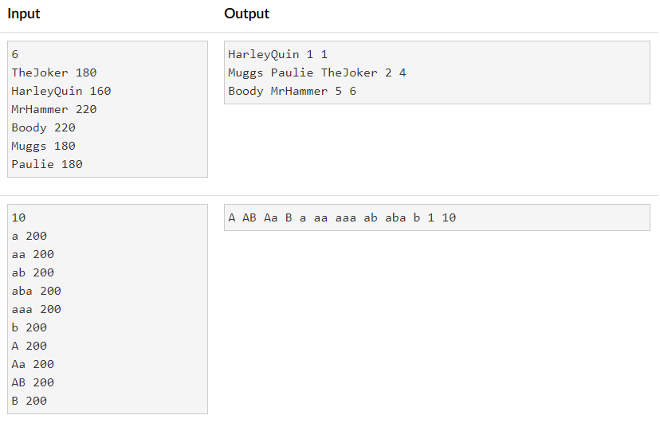

03 :

<https://csacademy.com/ieeextreme-practice/task/troll-coder/>

# Troll Coder

Time limit: 1000 ms  
Memory limit: 256 MB

You have found a huge treasure on an island, but the only access point to that island is a bridge guarded by a giant Troll! In order to cross the bridge, you have to guess a sequence of *N* bits by submitting queries. For each query, the Troll will tell you how many bits you guesses correctly until you guess the correct sequence.

## Interaction

Your program must exchange information with the Troll by submitting queries and reading answers.

Note that you must flush the buffer so that the output reaches the Troll. [Here](https://csacademy.com/contest/archive/task/interactive-partial-sums/solution/) we ilustrate it for several languages.

At the beginning of each test case, the Troll will give you a single integer *N* which will represent the length of the sequence.

To submit a query, your program should output the letter Q followed by a space and by a binary sequence of length *N* with each bit separated by a space. After each query you will receive an integer denoting the number of correct bits. The last submission will be your final answer and it should start with an A followed by a space and by a binary sequence of length *N* with each bit separated by a space.

## Constraints and notes

* This task is **NOT** **adaptive**
* 1 < *N* < 100
* 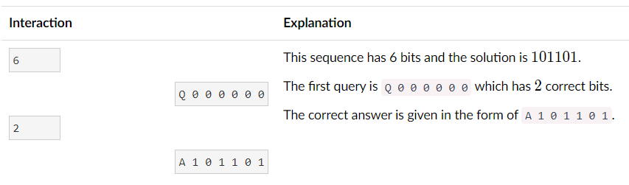Your program can submit at most *N*+1 queries before arriving at the correct answer.